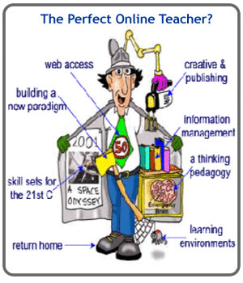

**Retrieved from http://www.theenglishteacheronline.com/the-perfect-online-teacher**